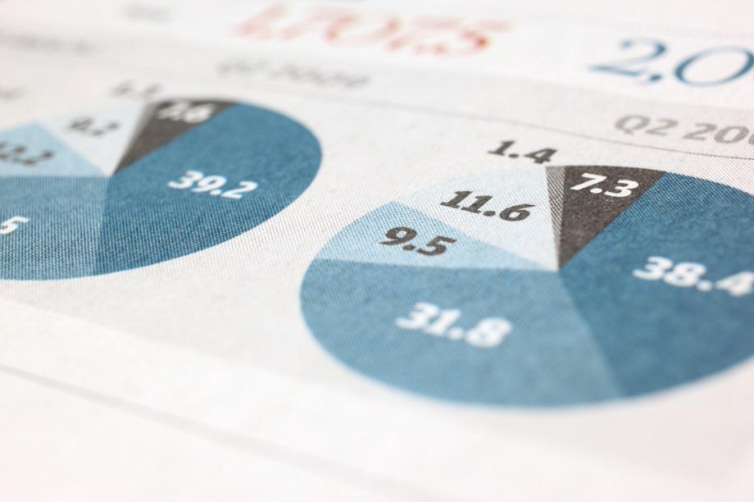
BLOOMEX.CA LOGISTICS OPTIMIZATION
GROUP 1: Joseph Choi, Bindu Nithyananda, Ujjwal Sharma, Nishu Dangal
Li, Yang | 10/4/25 | MSBA204

BLOOMEX.CA LOGISTICS OPTIMIZATION

MSBA204 TEAM CASE STUDY 1
BLOOMEX.CA LOGISTICS OPTIMIZATION
Refer to the case “Bloomex.CA Logistics Optimization” from Harvard Business Publishing Course pack. Your team is tasked to develop an optimal shipping plan for Bloomex using a Linear Programming (LP) Distribution (Network Flow) Model.
Total Point: 50 points

ASSIGNMENT TIMELINE AND REQUIREMENTS

PART 1. NETWORK STRUCTURE AND LP FORMULATION (Q1 & Q2)

TIMELINE: Sep 30 – Oct 6

SUBMISSION: Submit your answer to Q1 and Q2 by 11:59pm, Oct 6 (Monday)

Q1. Network Flow Diagram Construction (10 points)

Read the case and construct a comprehensive network flow diagram that includes:
- A visual representation of the logistics network
- Supply points with supply quantity marked
- Transshipment facilities with supply quantity marked (if applicable)
- Demand locations with demand requirements
- Connecting arcs between all relevant nodes.

Note:
- Go to page 41 of Week 6 Slides for a reference of a Network Flow Diagram
- This problem represents an extended transshipment model with variations from the example shown in class
- For simplicity, you do not need to include the transportation cost information on the diagram
- You may hand-draw the diagram or use any digital tool to create one. Ensure your diagram is clear, aesthetically pleasing, and all information is labeled without ambiguity.

Setup
Origin | Type | Supply
South America | Pure Supply | 1,050
Southeast Asia | Pure Supply | 30
Europe | Pure Supply | ∞
ON (Toronto) | Hybrid (Supply + Hub) | 100
Total |  | ∞

Destination | Type | Demand
Calgary | Pure Demand | 171
Winnipeg | Pure Demand | 64
Ottawa | Pure Demand | 127
Montreal | Pure Demand | 184
Halifax | Pure Demand | 64
ON (Toronto) | Hybrid (Demand + Hub) | 381
FL (Miami) | Pure Hub | 0
Vancouver | Hybrid (Demand + Hub) | 191
Total |  | 1,182

 | Cost: Origins to Transshipment
 | To
From | ON (Toronto) | FL (Miami) | Vancouver
South America | 14 | 9 | 20
Southeast Asia | 35 | 20 | 35
Europe | 30 | 15 | 35
ON (Toronto) | 0 | 10,000 | 15

 | Cost: Transshipment to Destination
 | To
From | Calgary | Winnipeg | Ottawa | Montreal | Halifax | ON (Toronto) | Vancouver
Toronto | 14 | 13 | 3.5 | 3.5 | 4 | 0 | 15
FL (Miami) | 10 | 10 | 7.5 | 7.5 | 10 | 5 | 10
Vancouver | 7 | 8 | 14 | 14 | 22 | 14 | 0
Notes:
- Unbalanced Model: Total supply exceeds total demand. This makes the model unbalanced, so supply constraints are written with “≤” while demand constraints use “=” to ensure each demand point is fully satisfied.
- Ontario (Toronto): Functions as both an origin and a hub. It contributes 100 units of supply, which can be shipped into the hub layer and redistributed to demand locations.
- Ontario (Toronto) and Vancouver: Functions as both a hub and a destination. They redistribute shipments like hubs, but also have their own local demand that must be satisfied.
- Miami (Florida): Functions strictly as a hub. It redistributes flows but does not have any final demand associated with it.

Q1 Network Flow Diagram
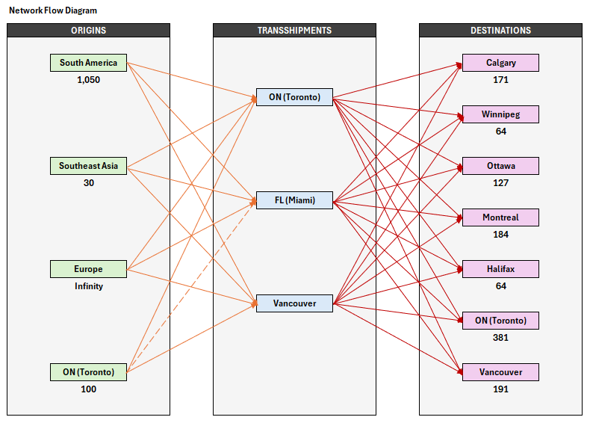

Network Flow Detail
Arc Type | From Node | To Node | Color
ORIGIN to HUB | South America | ON (Toronto) HUB | Orange
 | South America | FL (Miami) HUB | Orange
 | South America | Vancouver HUB | Orange
 | Southeast Asia | ON (Toronto) HUB | Orange
 | Southeast Asia | FL (Miami) HUB | Orange
 | Southeast Asia | Vancouver HUB | Orange
 | Europe | ON (Toronto) HUB | Orange
 | Europe | FL (Miami) HUB | Orange
 | Europe | Vancouver HUB | Orange
 | ON (Toronto) ORIGIN | ON (Toronto) HUB | Orange
 | ON (Toronto) ORIGIN | FL (Miami) HUB | Orange
 | ON (Toronto) ORIGIN | Vancouver HUB | Orange
HUB to DEST | ON (Toronto) HUB | Calgary | Red
 | ON (Toronto) HUB | Winnipeg | Red
 | ON (Toronto) HUB | Ottawa | Red
 | ON (Toronto) HUB | Montreal | Red
 | ON (Toronto) HUB | Halifax | Red
 | ON (Toronto) HUB | ON (Toronto) DEST | Red
 | ON (Toronto) HUB | Vancouver DEST | Red
 | FL (Miami) HUB | Calgary | Red
 | FL (Miami) HUB | Winnipeg | Red
 | FL (Miami) HUB | Ottawa | Red
 | FL (Miami) HUB | Montreal | Red
 | FL (Miami) HUB | Halifax | Red
 | FL (Miami) HUB | ON (Toronto) DEST | Red
 | FL (Miami) HUB | Vancouver DEST | Red
 | Vancouver HUB | Calgary | Red
 | Vancouver HUB | Winnipeg | Red
 | Vancouver HUB | Ottawa | Red
 | Vancouver HUB | Montreal | Red
 | Vancouver HUB | Halifax | Red
 | Vancouver HUB | ON (Toronto) DEST | Red
 | Vancouver HUB | Vancouver DEST | Red

Q2. LP Formulation (15 points)

Create an LP Formulation BASED ON your network diagram, including
- Clear definition and notation of all decision variables
- Expression of objective function
- Expression of all constraints with comments. (15 points)

Note: there are multiple ways to visualize the network. Ensure your LP formulation aligns with your network. If the LP formulation does not match the network structure (i.e. answers to Q1 and Q2 do not match), 5 points will be deducted even if individual answer is correct.

Q2 LP Formulation

Location Code:
Name | Code
South America | SAM
Southeast Asia | SEA
Europe | EUR
ON (Toronto) ORIGIN | ONO
ON (Toronto) HUB | ONH
FL (Miami) HUB | MIA
Vancouver HUB | VAH
Calgary | CAL
Winnipeg | WIN
Ottawa | OTT
Montreal | MTL
Halifax | HAL
ON (Toronto) DEST | OND
Vancouver DEST | VAD
Decision Variables:
X_{i,j} = Units shipped from Origin i to Transshipment j
- i = SAM, SEA, EUR, ONO
- j = ONH, MIA, VAH

X_{j,k} = Units shipped from Transshipment j to Destination k
- j = ONH, MIA, VAH
- k = CAL, WIN, OTT, MTL, HAL, OND, VAD

Objective Function:
Minimize Total Transportation Cost =
Origins to Hubs
14X_{SAM,ONH}​ + 9X_{SAM,MIA} ​+ 20X_{SAM,VAH}​ +
35X_{SEA,ONH} ​+ 20X_{SEA,MIA} ​+ 35X_{SEA,VAH}​ +
30X_{EUR,ONH} ​+ 15X_{EUR,MIA} ​+ 35X_{EUR,VAH} ​+
0X_{ONO,ONH}​ + 10,000X_{ONO,MIA} + 15X_{ONO,VAH} + (Assigning high cost to ONO to MIA)
Hubs to Destinations
14X_{ONH,CAL}​ + 13X_{ONH,WIN}​ + 3.5X_{ONH,OTT} ​+ 3.5X_{ONH,MTL} ​+ 4X_{ONH,HAL} ​+ 0X_{ONH,OND} ​+ 15X_{ONH,VAD} ​+
10X_{MIA,CAL} ​+ 10X_{MIA,WIN}​ + 7.5X_{MIA,OTT} ​+ 7.5X_{MIA,MTL}​ + 10X_{MIA,HAL}​ + 5X_{MIA,OND} ​+ 10X_{MIA,VAD}​ +
7X_{VAH,CAL} ​+ 8X_{VAH,WIN} ​+ 14X_{VAH,OTT}​ + 14X_{VAH,MTL} ​+ 22X_{VAH,HAL​} + 14X_{VAH,OND}​ + 0X_{VAH,VAD}

Constraints:
Supply Constraints
X_{SAM,ONH}​ + X_{SAM,MIA} ​+ X_{SAM,VAH} ​≤ 1050 (South America supply limit)
X_{SEA,ONH​} + X_{SEA,MIA} ​+ X_{SEA,VAH} ​≤ 30 (Southeast Asia supply limit)
X_{EUR,ONH}​ + X_{EUR,MIA}​ + X_{EUR,VAH} ​≤ ∞ (Europe unlimited supply)
X_{ONO,ONH} ​+ X_{ONO,VAH} ​≤ 100​ (Ontario supply limit)
Demand Constraints
​X_{ONH,CAL} ​+ X_{MIA,CAL} ​+ X_{VAH,CAL}​ ​= 171 (Calgary demand)
X_{ONH,WIN}​ + X_{MIA,WIN} ​+ X_{VAH,WIN}​ ​= 64 (Winnipeg demand)
X_{ONH,OTT}​ + X_{MIA,OTT} ​+ X_{VAH,OTT} ​ ​= 127 (Ottawa demand)
X_{ONH,MTL}​ + X_{MIA,MTL} ​+ X_{VAH,MTL} ​= 184 (Montreal demand)
X_{ONH,HAL}​ + X_{MIA,HAL}​ + X_{VAH,HAL}​ ​= 64 (Halifax demand)
X_{ONH,OND}​ + X_{MIA,OND} ​+ X_{VAH,OND} ​= 381 (Ontario demand)
X_{ONH,VAD}​ + X_{MIA,VAD}​ + X_{VAH,VAD}​ = 191​ (Vancouver demand)
Flow Balance
​ONH:
X_{SAM,ONH}​ + X_{SEA,ONH}​ + X_{EUR,ONH} ​+ X_{ONO,ONH}​ =
X_{ONH,CAL}​ + X_{ONH,WIN}​ + X_{ONH,OTT} ​+ X_{ONH,MTL}​ + X_{ONH,HAL} ​+ X_{ONH,OND} ​+ X_{ONH,VAD}​ (Ontario hub balance)
MIA:
X_{SAM,MIA}​ + X_{SEA,MIA} ​+ X_{EUR,MIA}​ =
X_{MIA,CAL} ​+ X_{MIA,WIN}​ + X_{MIA,OTT}​ + X_{MIA,MTL}​ + X_{MIA,HAL} ​+ X_{MIA,OND} ​+ X_{MIA,VAD} (Miami hub balance)
​VAH:
X_{SAM,VAH}​ + X_{SEA,VAH}​ + X_{EUR,VAH}​ + X_{ONO,VAH} ​=
X_{VAH,CAL}​ + X_{VAH,WIN}​ + X_{VAH,OTT} ​+ X_{VAH,MTL}​ + X_{VAH,HAL} ​+ X_{VAH,OND} ​+ X_{VAH,VAD}​​ (Vancouver hub balance)
Non-Negativity
X_{i,j​} ≥ 0, X_{j,k} ​ ≥ 0 for all defined arcs (No negative shipments)

Updates Made After Feedback:
- Decision variable definitions were revised for consistency with the location code table, ensuring each node’s role is clearly represented
- Added the dummy arc ONO to MIA in the network flow diagram and in the objective function with high cost (10,000) to maintain model completeness

Note on Class Discussion: Solutions to Q1 and Q2 will be discussed in class on October 7 to allow student teams to identify any errors before proceeding to the problem-solving phase. Students teams are expected to make correction to the diagram and LP formulation before proceeding to Q3 and Q4 (resubmit the diagram and LP formulation if major changes are made). This does NOT mean mistakes in Q1 and Q2 will be waived — this only ensures teams will not receive further penalties in Q3-4 based on errors from Q1-2 or inconsistencies between answers to Part 1 and Part 2.

Q3: LP Problem Solving (15 points)
Solve the LP problem using either Excel Solver or Python.
Submit the spreadsheet or python code with printed solutions and sensitivity analysis.
Answer:
Attached the ipynb file.
We mapped out the whole shipping network: We listed all the flower suppliers (like South America and Europe), the main warehouse hubs (Miami, Toronto, Vancouver), and all the Canadian cities that need flowers. We also gathered all the shipping costs between these places. We built a math model to find the cheapest plan: Using Python, we created an optimization model that automatically calculates the best shipping routes. Its only job was to minimize the total shipping cost while making sure every city gets exactly the flowers it needs. We found the perfect shipping plan: The model spit out the answer, the absolute cheapest way to ship everything costs $18,503.50 per week. The coolest part was seeing that almost everything should go through the Miami hub. It turns out that even though Miami is far, it's the central point that makes the overall shipping costs the lowest. We figured out how to save even more money: Finally, we used the model's "sensitivity analysis" to see what would happen if we changed things. We learned that getting more flowers from the Toronto grower would save the company $20 per extra box, and more from South America would save $6 per box. This is super useful info for the company when deciding which growers to work with more.

Q4. Optimal Solution Report and Sensitivity Analysis (10 points)
In a word document, provide:
Result Summary (5 points)
• Minimum total cost of the optimal Bloomex shipping plan
• Detailed description of the optimal shipping plan, specifying exact quantities shipped
between locations. (this could be extract from an excel result table)
• A result diagram (similar to page 49 of Week 6 Slides)
Answer:
After running the optimization model, we found that the cheapest possible weekly cost for Bloomex to ship all its flowers is $18,503.50.
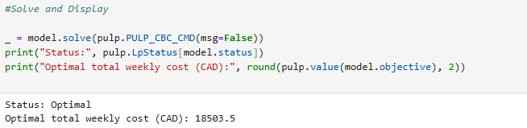
Basically, almost everything gets funneled through the Miami hub. The 705 boxes from South America and 32 boxes from Europe are all sent to Miami first. The local Toronto grower sends all 100 of its boxes directly to the Toronto hub and 345 boxes from South America get funneled to the Toronto hub. From there, the Miami hub does most of the heavy lifting, shipping boxes out to meet almost all the demand across Canada. It sends the exact number of boxes needed to Calgary (171), Winnipeg (64), Ottawa (127), Montreal (184), and Vancouver (191). It also sends a massive shipment of 345 boxes to the Toronto distribution center to help meet the high local demand. The Toronto hub, which received the 445 local boxes, uses them to cover the remaining demand in its own city (381 boxes) and sends 64 boxes all the way to Halifax.
Optimal shipping plan:
From Origins - Hub(s)
South America - Miami: 705
South America – ON (Toronto) Hub: 345
Europe - Miami: 32
ON (Toronto) Origin - ON (Toronto) Hub: 100
From Hubs - Destinations
Miami - Calgary 171; Winnipeg 64; Ottawa 127; Montreal 184; Vancouver 191; ON
(Toronto) 345
ON (Toronto) Hub - Halifax 64; ON (Toronto) 381

2) Sensitivity Analysis (5 points)
Use the information in the sensitivity analysis to answer the following questions:
• What would be the gains from additional supply made available from each of the
growers?
• How much would you be willing to pay for each box and how many boxes would you
order from each source?
Answer:
The sensitivity analysis tells us how the solution would change if we had a little more or a little less of something, like supply from our growers.
First, looking at the potential gains from additional supply, the key number is the "shadow price." This tells us how much we would save on our total cost for each extra box we get. For the South American grower, the shadow price is -6. This means for every additional box we can get from them, our total weekly cost would go down by $6. That’s a pretty significant saving. Even more impressive is the Toronto grower, which has a shadow price of -20. An extra box from them would save us $20. This makes sense because local boxes don’t need expensive international shipping to a hub. The Southeast Asian grower has a shadow price of 0, meaning getting more boxes from them wouldn't save us any money. In fact, our current optimal plan doesn't even use any of their 30 boxes!
Now, how much would we be willing to pay for each box? The shadow price is basically the answer. It’s the maximum extra amount we should be willing to pay on top of the current cost for an additional box. So, we should be willing to pay up to $6 more per box to get extra flowers from South America. For the Toronto grower, we should be willing to pay up to a whopping $20 more per box because of the massive savings it creates in our overall shipping network. We wouldn't be willing to pay anything extra for boxes from Southeast Asia since they don't help our costs.
The marginal value is the highest premium that can be paid for an additional box from that source before the plan is altered:
- South America: up to $6 per box
- Southeast Asia: $0 per box
- Ontario (ONO): up to $20 per box
- Europe: $0 per box (unrestricted)

The number of boxes that should be ordered from each source:
- South America: 1050 boxes
- Southeast Asia: 0 boxes
- Ontario: 100 boxes
- Europe: 32 boxes (routed via Miami; observe that the model does not impose any restrictions on Europe.)

In terms of how many boxes to order, we should order as many as possible from the Toronto and South American growers. The model shows their current supply is completely used up, and getting more would directly make the entire operation cheaper. We wouldn't order any more from Southeast Asia since we aren't even using what they currently offer.

